Project Report
Script-Controlled ACL - Restrict Record Access Based on Field Value
Team ID: SWTID-2026-8643
Platform: ServiceNow

Table of Contents
- Introduction
- Ideation Phase
- Requirement Analysis
- Project Design
- Project Planning & Scheduling
- Functional and Performance Testing
- Results
- Advantages & Disadvantages
- Conclusion
- Future Scope
- Appendix

1. INTRODUCTION

1.1 Project Overview
This project uses script-controlled Access Control Lists (ACLs) in ServiceNow to manage who can view, create, edit and delete records in the custom Institution Details table (u_institution_details). Users receive custom roles (bb1 to bb4), while the READ ACL combines the role requirement, a Branch condition (EEE) and an advanced script. The bb1 role allows EEE records only, users without the role see no records, and administrators retain full access.
1.2 Purpose

2. IDEATION PHASE
2.1 Problem Statement

2.2 Empathy Map Canvas
Persona: an EEE branch coordinator who works with student records. The map below is a draft for the team to refine.
Says | Thinks
"I should only see EEE students." "Who can delete these records?" | Other branches' data is not my business. A wrong edit or deletion would be hard to undo.
Does | Feels
Opens the Institution Details list, searches students, updates descriptions. | Confident when only relevant records appear; concerned when sensitive data is visible to everyone.

2.3 Brainstorming
Options the team considered for restricting access:
Idea | Outcome
Role-only ACL on the table | Simple, but cannot limit records by Branch
ACL with a data condition (Branch is EEE) | Limits records by field value; selected
Script-controlled ACL (advanced) | Allows custom logic such as the admin check; selected
Separate ACL per operation (read, create, write, delete) | Gives fine control with roles bb1 to bb4; selected
Separate tables per branch | Rejected: duplicates data and is harder to maintain

3. REQUIREMENT ANALYSIS

3.1 Customer Journey Map
Stage | User action | Experience / outcome
Sign in | EEE User signs in (or is impersonated) | Access depends on the assigned roles
View records | Opens u_institution_details.list | Sees only EEE records (bb1)
Add a record | Clicks New | Button shown only with bb2
Stage | User action | Experience / outcome
Edit a record | Edits Description in the list | Allowed only with bb3
Delete a record | Actions > Delete, confirms | Allowed only with bb4

3.2 Solution Requirement
ID | Requirement | Type
FR-1 | Create a user and custom roles bb1, bb2, bb3, bb4 | Functional
FR-2 | Create table u_institution_details with Branch, Email, Phone Number and other fields | Functional
FR-3 | READ ACL: show only EEE records to bb1 users; admins see all | Functional
FR-4 | CREATE, WRITE and DELETE ACLs tied to bb2, bb3 and bb4 | Functional
NFR-1 | Unauthorized users must see no records | Security
NFR-2 | ACL evaluation should not noticeably slow list loading | Performance

3.3 Data Flow Diagram
User
(
role: bb1-bb
4)
Request
(
list/create/edit/delete
)
ACL check
(
role+condition+script
)
Institution
Details table
Figure 1: Data flow of an access request

3.4 Technology Stack
Component | Technology
Platform | ServiceNow instance (Global application scope)
Data | Custom table u_institution_details (fields: auto number, reference, choice, string)
Security | Roles, record ACLs (read, create, write, delete), data conditions
Scripting | Server-side JavaScript (ECMAScript 2021 mode) using gs.hasRole()
Testing | User impersonation and elevated security_admin role

4. PROJECT DESIGN

4.1 Problem Solution Fit
Problem | Solution
All branch records visible to every user | READ ACL with Branch is EEE and role bb1
Anyone could add, edit or delete | Separate ACLs requiring bb2, bb3, bb4
Admins must not be locked out | Admin check in the script and Admin overrides

4.2 Proposed Solution
ACL operation | Required role | Condition | Effect
Read | bb1 | Branch is EEE + script | Only EEE records visible; admin sees all
Create | bb2 | None | New button available
Write | bb3 | None | Fields can be edited
Delete | bb4 | None | Records can be deleted

4.3 Solution Architecture
Users
(
admin, EEE User
)
Roles
bb1, bb2, bb3, bb4
ACLs
read, create,
write, delete
Table
u_institution_
details
Figure 2: Solution architecture

5. PROJECT PLANNING & SCHEDULING

5.1 Project Planning
The lab is planned for 3 hours. The split below is a suggested schedule; adjust it to your actual timeline.
Milestone | Activity | Suggested time
1 | Create user and roles bb1 to bb4 | 20 min
2 | Create table, fields and sample records | 30 min
3 | Create and verify READ ACL | 40 min
4 | Create and verify CREATE ACL | 15 min
5 | Create and verify WRITE ACL | 15 min
6 | Create and verify DELETE ACL | 15 min
7 | Testing and verification | 25 min
8 | Documentation | 20 min

6. FUNCTIONAL AND PERFORMANCE TESTING

6.1 Performance Testing
Test ID | Scenario | Expected result | Result
FT-01 | Text input validation (Email, Branch, user references) | Valid inputs accepted | Pass
FT-02 | Number input (auto Roll Number, Phone Number) | Roll Number auto-generates | Pass
FT-03 | Access control by role (READ, CREATE, WRITE,  DELETE) | Each role gets only its permitted actions | Pass
FT-04 | Instance / ACL connection check | ACLs save and take effect | Pass
PT-01 | List load time | Under 3 seconds | Pending
PT-02 | Concurrent access | No slowdown | Pending
PT-03 | Bulk data load | Loads without errors | Pending
Performance tests were not measured in the lab and remain pending. Overall validation accuracy of the role-based tests was 100%.

7. RESULTS

7.1 Output Screenshots
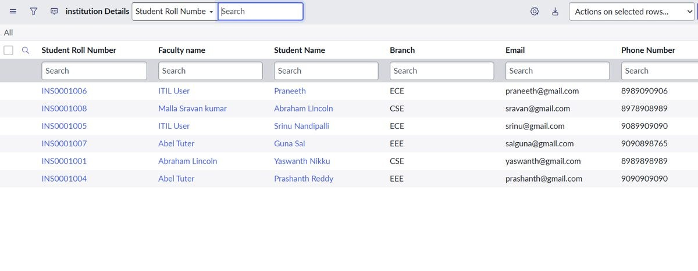
Figure 3: Institution Details records (admin view)
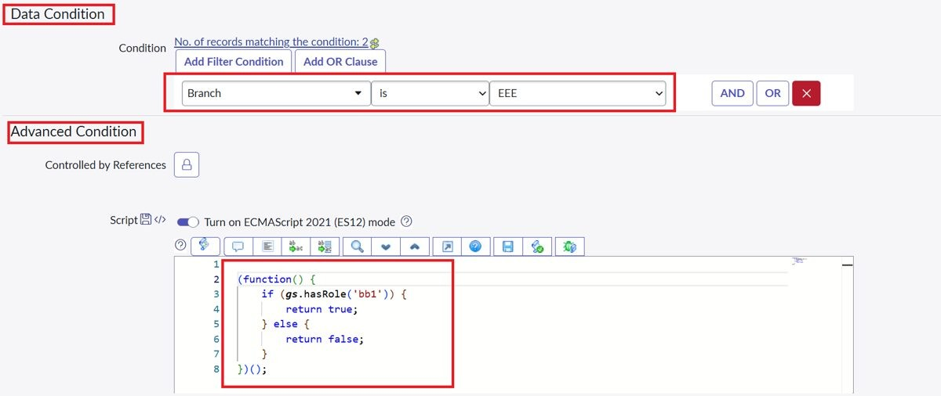
Figure 4: READ ACL data condition (Branch is EEE) and script
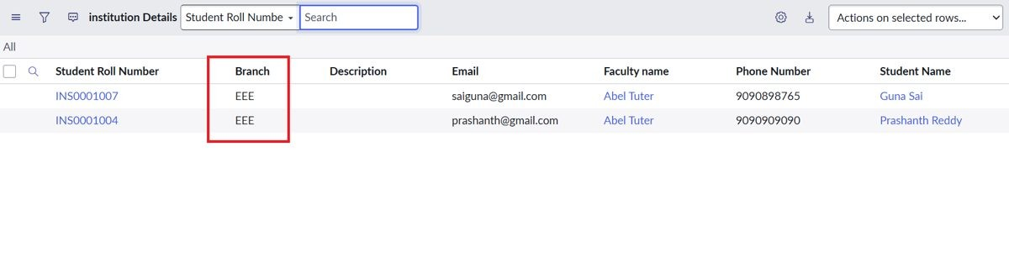
Figure 5: User with bb1 role sees only EEE records
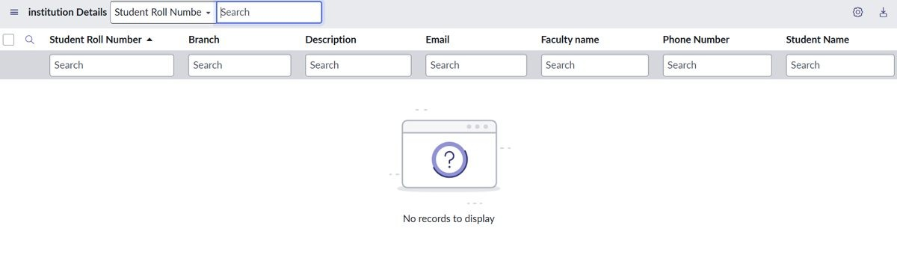
Figure 6: User without the role sees no records
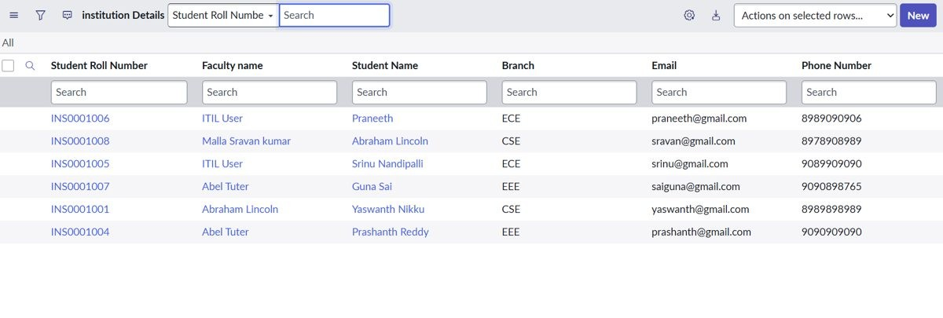
Figure 7: Admin sees all records
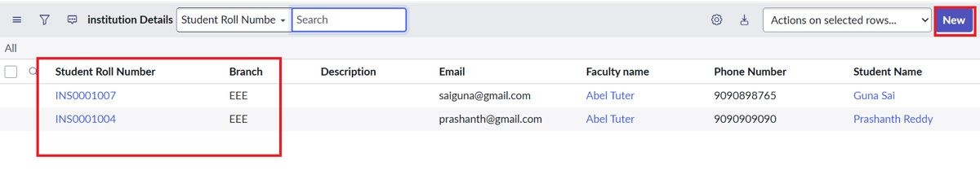
Figure 8: bb1 and bb2 users see EEE records with the New button
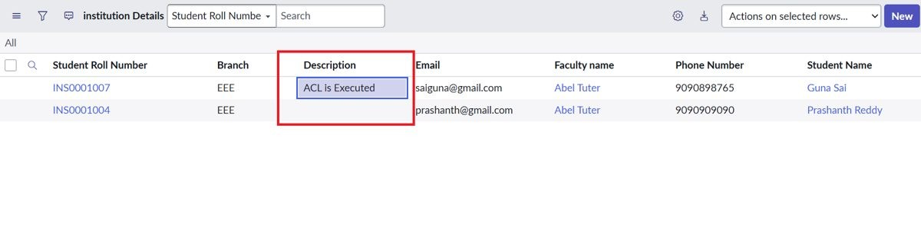
Figure 9: bb3 user edits the Description field
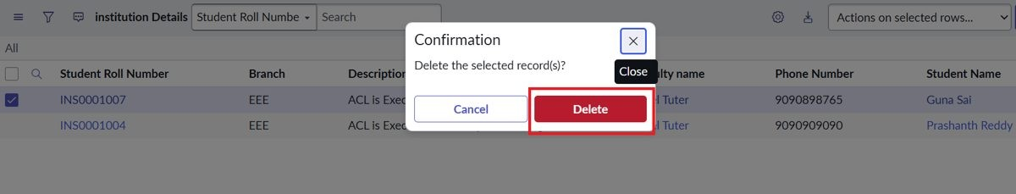
Figure 10: bb4 user deletes a record (confirmation)

8. ADVANTAGES & DISADVANTAGES
Advantages | Disadvantages
Record-level security based on role and field value | Roles and ACLs must be maintained as branches grow
Separate control over read, create, write and delete | Script-based ACLs need care to avoid errors
Admins keep full access | Branch-specific logic is hard-coded to EEE and bb1
No data duplication across tables | Each additional branch needs new roles or conditions

9. CONCLUSION
The project shows that script-controlled ACLs can enforce record-level security in ServiceNow. Users with bb1 see only EEE records, users without the role see nothing, and admins see everything, while bb2, bb3 and bb4 independently control creating, editing and deleting. The functional tests passed; the performance tests remain to be measured.

10. FUTURE SCOPE
- Use field-level ACLs to hide sensitive fields such as Email and Phone Number.
- Replace the hard-coded role check with a group or branch-based lookup.
- Extend the same ACL pattern to Service Portal forms and lists.
- Build a dashboard of records by branch.

11. APPENDIX

Source Code
READ ACL script (from the lab instructions):
(function () { // Allow admin users full access if (gs.hasRole('admin')) { return true; } // Allow only EEE branch users to see EEE records if (gs.hasRole('bb1')) { return true; } // Deny access for all others return false; })();
Dataset Link
Not applicable. Sample records were entered manually in the Institution Details table.

GitHub & Project Demo Link
[Add your GitHub repository link]
[Add your project demo video link]

